# CS 255 System Design Document Template

This template lays out all the different sections that you need to complete for Project Two. Each section has guidance to prompt your thinking. You will need to continually reference the interview transcript as you work to make sure that you are addressing your client’s needs. There is no required length for the final document. Instead the goal is to complete each section based on what your client’s needs are. Remove this note when you are finished, and replace all bracketed text with the relevant information.

## UML Diagrams

### UML Use Case Diagram

### UML Activity Diagrams

### UML Sequence Diagram

### UML Class Diagram

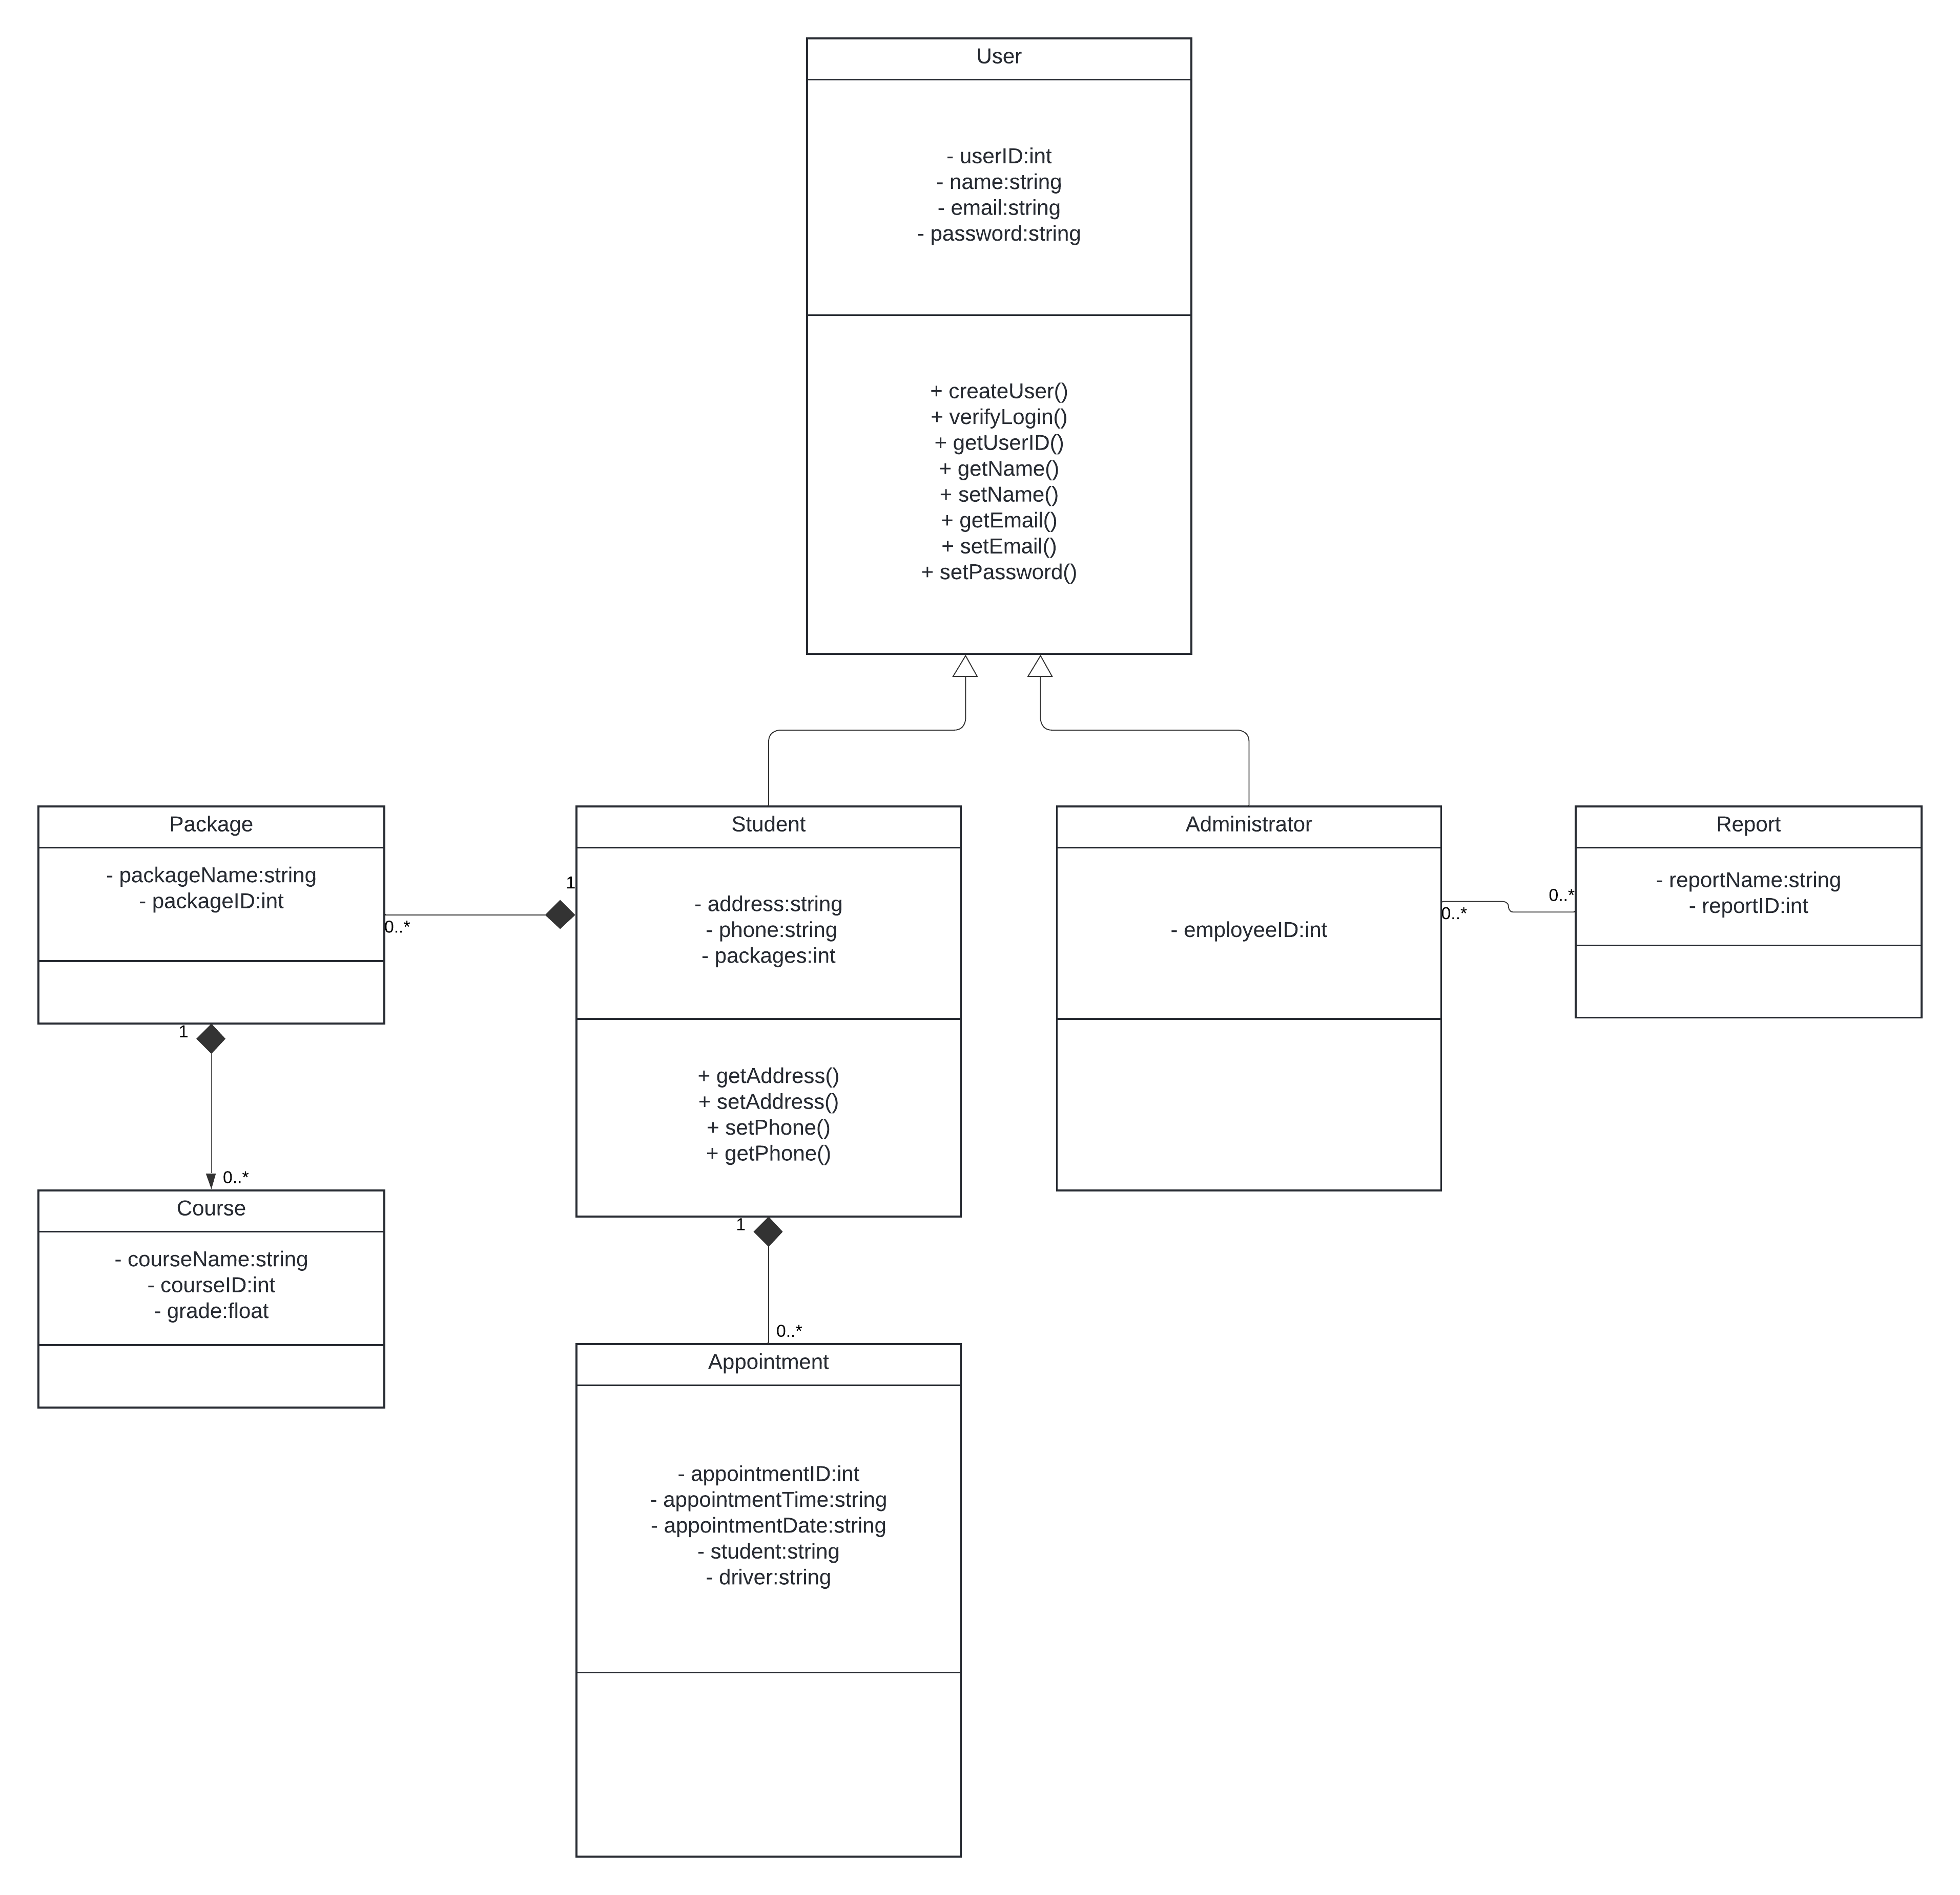

## Technical Requirements

Hardware:

* Server running DriverPass System, utilizing cloud infrastructure.
* Storage for backups.

Software:

* Linux operating system.
* Databases to store data.
* Backup software to maintain backups.
* Firewall software to prevent unauthorized access.

Tools/Infrastructure:

* Integration with a payment processor to handle payments.
* Server-client architecture enabling users to access the service via web browser.
* Integration with DMV to acquire learning resources.